**Amb. Dr. Naser Al Belooshi**

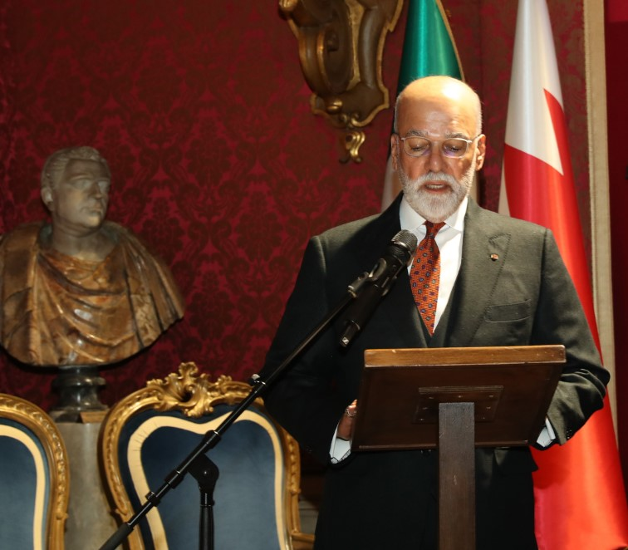**Ambassador of the Kingdom of Bahrain to the Italian Republic**

Ladies and Gentlemen,

As I stand here today, reflecting on my four-year tenure as the Ambassador of the Kingdom of Bahrain to the Italian Republic, my heart is filled with a profound sense of gratitude and appreciation for this magnificent country and its gracious people.

My journey in Rome has been an enriching experience, both personally and professionally. Italy, a land steeped in history, culture, and innovation, has been a gracious host. The warmth and hospitality of the Italian people have made my stay immensely fulfilling and have left an indelible mark on my heart.

One of the cornerstones of our shared success has been the significant enhancement of trade relations between Bahrain and Italy. Today, Italy is the first trade partner among the EU countries (the total volume in 2020 amounted to $634 million, while in 2022 it reached $954.8 million) and I am expecting it to increase because of the projects underway in Bahrain and in the GCC countries. This remarkable achievement has been greatly facilitated by the growing role of the Italy-Bahrain Business Council. Through their unwavering efforts, the Council has been instrumental in fostering trade and investment, paving the way for a future of shared prosperity and mutual growth. The fruits of this collaboration are a testament to our shared vision and dedication to economic development. The Economic Development Board has also facilitated Italian investment in the Kingdom of Bahrain, thus adding more fund to the mother company here in Italy.

Moreover, our collaboration has extended beyond trade, encompassing culture, education, health and maritime security. The cultural exchanges and educational partnerships have enriched the fabric of our societies, fostering a deeper understanding and mutual respect. In the health sector, our joint efforts, particularly in challenging times, have underscored our commitment to the well-being and health of our people.

I must emphasize the invaluable role of the Italian Senate and Parliament in this journey. Their support and engagement have been crucial in facilitating and enhancing the diplomatic and economic ties between Bahrain and Italy. The collaboration and dialogue fostered through these esteemed bodies have greatly contributed to the strengthening of our bilateral relations, setting a foundation for enduring partnership and mutual respect.

I would be remiss if I did not acknowledge the vital role played by the Ministry of Foreign Affairs and International Cooperation in both our countries. Their guidance and support have been pivotal in strengthening the ties between Bahrain and Italy. Their vision and dedication have been a guiding light in our journey towards building a robust and dynamic relationship.

I extend my deepest gratitude to H.E Paola Amadei, the Ambassador of Italy in Bahrain, whose exceptional efforts have significantly contributed to nurturing and strengthening our bilateral relations. Her dedication is a beacon that lights the path of our shared journey. I want to tell you that we were in touch on weekly basis for better coordination and to enhance the relationship between our two nations and I assure you that it worked extremely well.

Last but not least, it is essential to acknowledge that none of this would have been possible without my incredible team at the embassy. From diplomats and local employees to housekeepers and our chef cook, every member, in his capacity, has contributed immensely to our mission's success. Their dedication, hard work, and commitment have been the backbone of our operations, ensuring that we represent the Kingdom of Bahrain with honour and efficiency.

As I bid farewell to this beautiful country, I am taking with me memories and experiences that will be treasured for a lifetime. The bonds of friendship and cooperation that we have built will continue to flourish, leaving a lasting legacy of collaboration and mutual respect between our two nations.

Looking ahead, I am confident that the relationship between Bahrain and Italy will grow even stronger. Though I depart from Italy, a part of me will forever remain here, intertwined with the spirit and beauty of this land and its people.

Thank you, Italy, for an unforgettable chapter in my diplomatic career. Arrivederci and grazie mille.

**Hon. Maria Tripodi**

**Undersecretary of State at the Ministry of Foreign Affairs and International Cooperation**

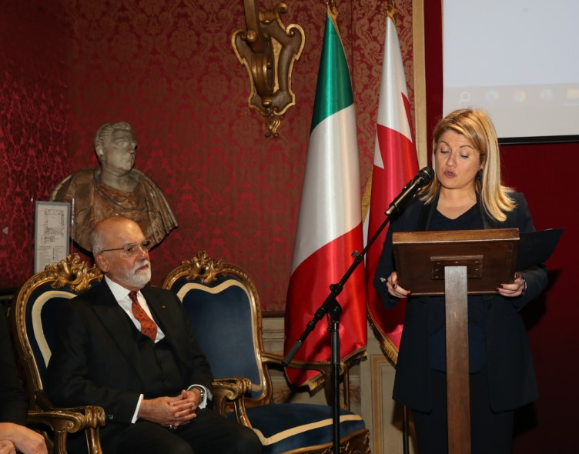

Your Excellency Ambassador, Ambassadors, Ladies and Gentlemen,

it is a great honor and immense pleasure for me to be here today on the occasion of the greeting of the Ambassador of the Kingdom of Bahrain to Italy, His Excellency Naser Al Belooshi.

Italy is very pleased with the strong friendship and bilateral relations between our countries, which are based on a relationship founded on loyalty, mutual trust, respect and building genuine human relations.

This achievement was also possible thanks to the fruitful dialogue that has been established between MAECI and Your Embassy. Bilateral relations between Italy and Bahrain have strengthened in recent years, especially since 2020, precisely with the inauguration of the Bahraini Embassy in Rome, the year in which - Ambassador - You were appointed Head of Mission. Your impetus has been instrumental in deepening the partnership between our countries.

Institutional dialogue is constant, as evidenced by contacts at the political level in both Rome and Manama. Let me recall the recent visit of His Highness King Hamad, who went on an official mission to Rome last October where he was received by President of the Republic Mattarella and Prime Minister Meloni.

There is ample scope for deepening bilateral cooperation. As for Italy, I confirm your willingness to deepen the partnership with your country in every area of mutual interest. Evidence of this is the meeting of the first Mixed Economic Commission, hosted at the Farnesina in June 2023 in the presence of the Minister of Foreign Affairs, His Excellency Al Zayani, which was a primary event to pave the way for more structured cooperation between our countries.

From the point of view of economic/commercial cooperation, for Italy Bahrain represents a partner of strategic interest in the MENA area with whom our interchange is constantly growing. We are also very pleased with the excellent level of bilateral relations in the defense sector.

Our partnership is based on a solid and deep-rooted presence of Italian companies in Bahrain that, over the years, have contributed to the country's industrial development. Our hope is that Italian companies, thanks to their globally recognized expertise, can be increasingly involved in Bahrain's major development projects, thus helping to strengthen the partnership that binds our countries.

But it is not only the economic/commercial sector where our collaboration is fruitful. I also want to mention the cultural, scientific and technological ones. We are also very pleased with the excellent collaboration with the Bahrain Authority for Culture and Antiquities, and we greatly appreciate the help it provides to the Italian Embassy in Manama to promote Italian culture in Bahrain with high-quality initiatives.

I believe that the promotion of the language and the mobility of students and researchers are crucial levers for strengthening economic and cultural relations between our countries, and for this reason, we are ready to collaborate to offer exchange opportunities to students and researchers and encourage the presence of Italian courses in Bahraini universities.

With Bahrain, Italy also maintains a fruitful dialogue on regional issues, a valuable dialogue for Rome because Manama represents in that quadrant an actor with which to discuss and face together the common challenges of our present time, so difficult and complex.

Your Excellency, in greeting you, thanking you for the extraordinary work you have done and wishing you all the best for the future, we await the arrival of the new Ambassador of the Kingdom of Bahrain in Rome to whom MAECI will provide all the necessary support. With the almost simultaneous arrival of the new Ambassador of Italy in Manama expected in March 2024, there are all the right conditions to strengthen even more the deep friendship that binds our countries and give a renewed impetus to the bilateral partnership, to which You have been able to give an exceptional impetus that I want to witness this evening.

Long live Italy, long live Bahrain and our friendship!

**Sen. Elena Murelli**

**Member of the Italy-Gulf Parliamentary Friendship Group**

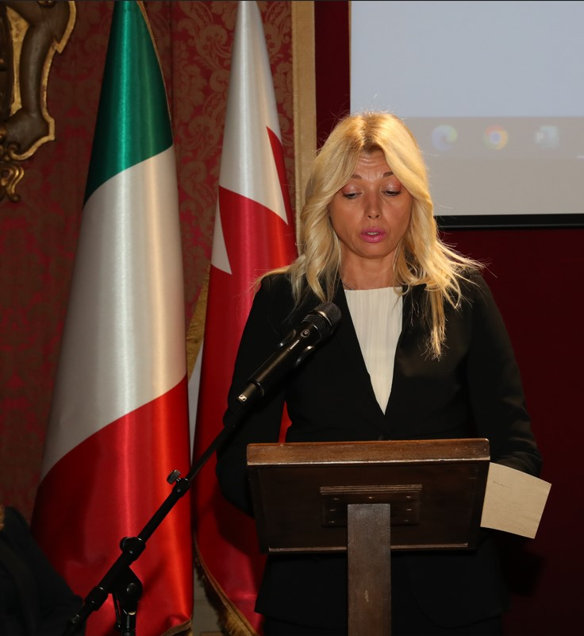

Mr. Ambassador,

I would like to thank you on behalf of the Italian Parliament and the President of the Italy-Bahrain Bilateral Friendship Section, Hon. Salvatore Caiata, who is not present here as he is on an institutional mission abroad, for your efforts during your stay in Italy.

I must acknowledge that Ella has always taken care of the relations between Italy and the Kingdom of Bahrain both at the governmental and parliamentary levels.

And I remember with real pleasure your last visit to the Chamber of Deputies on December 13, 2023, when you wanted to attend the inauguration of the Italy-Gulf States Bilateral Friendship Section of the Inter-Parliamentary Union. I was present at that meeting and was able to appreciate His love for our country.

Also in 2023, in March, she took care with professionalism and dedication of the Italian delegation that participated in the 146th Assembly of the Inter-Parliamentary Union held in Manama, which was attended by Parliamentarians Deborah Bergamini and Lia Quartapelle. Upon their return to Rome, the two parliamentarians expressed an extremely positive view of the welcome and assistance they received during their stay in Bahrain. This was, of course, thanks to His efforts.

Mr. Ambassador, the Italian Parliament follows your country with interest; a country that continues to grow thanks to the reforms that have been approved especially in recent years.

The main objective of Italy's action in Bahrain is the consolidation of bilateral actions that already record a constructive dialogue on international policy issues.

"Sistema Italia" has a long-standing presence in Bahrain since the 1970s-80s.

But especially in recent years, our country has confirmed this interest with numerous projects in the field of infrastructure and construction, as well as in the oil and petrochemical sector.

Intense is also the relationship of cultural collaboration. I want to mention here the "Day of Italian Design," "The Italian Language Week," "The Week of Italian Cuisine in the World."

Your Excellency, in thanking you once again, I would like to hope that you may, albeit in a different role, continue in your efforts aimed at consolidating and further developing cooperation with our country, with Italian companies, in order to promote Made in Italy.

**Ignazio Moncada**

**Co-Chairman of Italy-Bahrain Business Council**

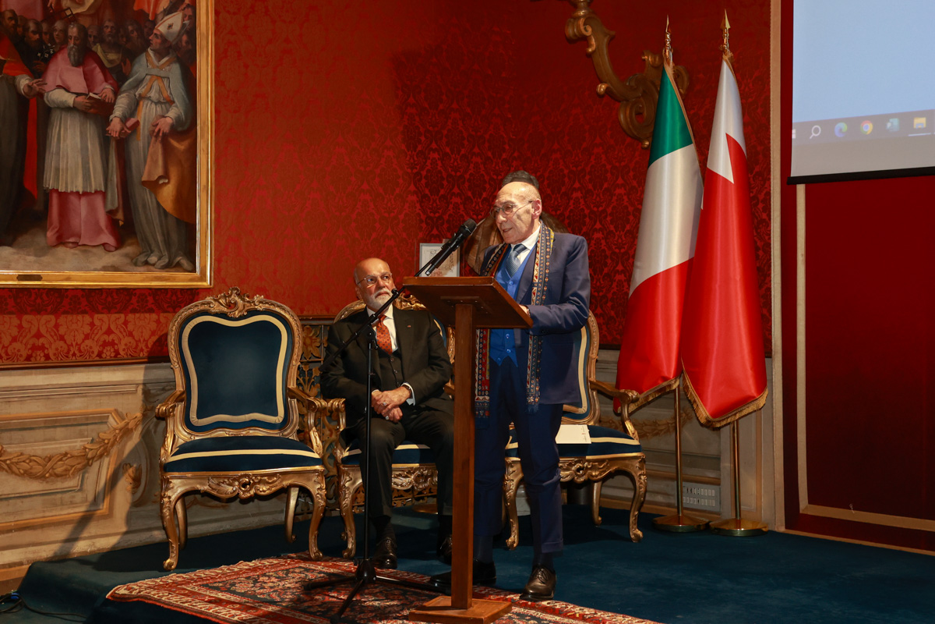

Dear Ladies and Gentlemen,

I am, of course, very sorry to hear of the departure for the end of the mission of H.E. Ambassador Naser Al Belooshi. This news, in some ways unexpected, was learned not only by me but by the entire Business Council with sincere regret.

Ambassador Al Belooshi represented a major boost to the development of Bahrain-Italy relations.

It was his and Ambassador Paola Amadei's idea to set up the Italy-Bahrain Business Council, an initiative they tenaciously pursued and which, with the contribution of important companies from the two countries, finally saw the light of day a couple of years ago.

During his years in Italy, Ambassador Al Belooshi spent all possible energies to bring awareness of Bahrain and its potential to all Italian institutions at all levels.

He has toured Italy from North to South meeting mayors of large and small cities, presidents of regions, as well as business associations.

He has successfully helped to establish bilateral collaborations in the cultural, scientific and industrial spheres.

And I want to mention here that, thanks to his specific skills and experience gained during his previous missions to Washington and Paris, he has contributed to the understanding of our institutions and businesses on the benefits of attracting investment to Italy through Islamic finance.

There is still work to be done in this regard, and I look forward as a Business Council to continuing this journey.

In my long working life I have truly rarely seen such an active, helpful and enthusiastic diplomat; and he deserves credit for these qualities!

A friend of Italy leaves us and, as I have already said, we will remember him for strengthening the friendship between our two nations and people.

I hope and indeed, we hope to welcome him again soon to our country as a prominent representative of Bahraini institutions or as a tourist, but above all, as a friend.

Thank you Ambassador for your excellent work in our country.

**Davide Allegra**

**Country Director for Italy of EDB Bahrain**

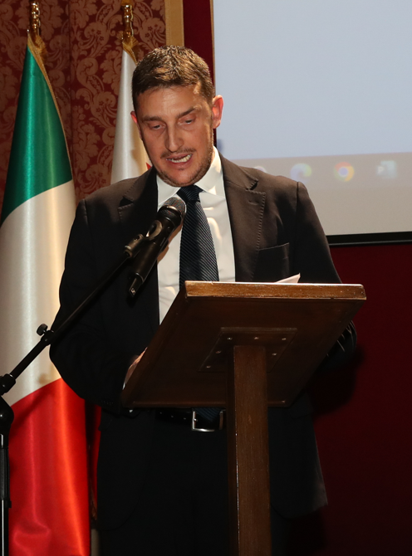Ambassador Al Balooshi, Distinguished Guests,

"Goodbyes mean little on their own. What matters is valuing the time we spent together, how we spent it and not how this ends."

Let me begin this speech of mine with a quote from American film producer and actor Trey Parker.

And I think this is perfectly true and perfectly reflects that we, as human beings, this evening certainly need to be together, to get together, to see each other again, not simply to want to say "goodbye" (not farewell) to Ambassador Al Balooshi, but the real reason we are here is to value, and by a great deal, the time we have spent together, the things we have accomplished and the results we have fought for together with you, Your Excellency. And this is exactly the case.

All the people in this room are here to thank You for being a sublime Chief of Mission in guiding the Italy-Bahrain relationship, which You have nurtured, empowered and deeply, substantially, energized over these four years.

All the distinguished guests are gathered here today to celebrate together what You have accomplished in working with each of us, in the various spheres and contingencies. All the people in this room are here to thank you for being a sublime Chief of Mission in guiding the Italy-Bahrain relationship, which you have nurtured, empowered and deeply, substantially, energized over these four years. All the distinguished guests are gathered here today to celebrate together what You have accomplished in working with each of us, in the various spheres and contingencies.

The passing of time can cloud memories for only a moment. This is precisely why I want to recall, Your Excellency, His Majesty King Hamad's visit to Rome last October; the Italy Roadshow that you conducted in collaboration with EDB Bahrain in Milan, Florence, Parma and Treviso in 2022; our three-day visit to Genoa and Turin in the previous year, as valuable time spent working together side by side, promoting the Kingdom of Bahrain as a prized investment destination in the Middle East region, and let me say ... much much much more.

Your Excellency, you will be proud to know that in 2022, a key member of EDB Bahrain's Senior Management team, Amb. Iain Lindsay, did not hesitate to tell me in person while I was there in Manama, "the MOFA-EDB relationship we have in the Italian market is one of the best, perhaps the best, in the entire international network of our organization." And this is only because of you.